The Beginning
My discovery of nutrition and the benefits of whole food ingredients did not come until much later in my life. I was young, high metabolism and burned off most of everything I ate. So what did I care!
​
It was not until I got married, and in my late thirties, that what I was accustomed to my body burning off was not easily burning off anymore. Through my marriage, I had gained 50lbs (3 years) and then through my divorce it got worse.
​
At the time of my divorce I had no escape, no mental escape and one day I put my head phones on, headed outside and began to walk, then jog, then run (ok so like a death run). It was awful! BUT, it gave me hope to feel better.
​
What I noticed first off, the weight was coming off, three years of it! Remember, I could barely walk a mile let alone run one. Little by little I accomplished small feats. I would hit that one mile run mark and feel like the world was at my feet. It was exhilarating and I was feeling better about myself; I was having this time with myself that was empowering and motivating!
​
I ran my first half marathon at 39 and at 40 I ran my first marathon with absolute no perception of what I was getting myself into. I bombed....mile 18 I fell apart, every muscle hurt, I couldn't finish, but I did! AND IT WAS AWESOME! The mental ability to stay focused and overcome what is happening to my body was challenging. I was addicted! So I ran! And I ran a lot!
​
This precedes for me to tell you the 2nd half of my story....

The Accident
In 2014 I was hit by a car, in a cross walk, going 45mph. I didn't see it coming. Went flying over the hood of her 92 Lincoln Continental land yacht and then landed in on coming traffic. The last thing I remember thinking, I am now going to die. I then woke up briefly in the street to a stranger helping me, spoke a few words, I was coherent (I think) and then woke up again in the ambulance and remember nothing until the hospital. The story will blow your mind. It made national news. Here ya go! https://www.nydailynews.com.
​
I suffered from a TBI, busted elbow, left knee injury and concussion. I barely remember the days after leaving the hospital. I was in and out of hospitals, doctors offices, and had many sleepless nights. I never paid much attention to my brain, until I lost it. The doctors wanted to cut into my head, put me on meds, and I refused. There was no way this was happening to me! I refused, and because I had no broken bones, I kept running, very very slowly.
​
In the meantime, I was finding other discoveries post accident: celiac, menopause, and awful knee pain. My brain was constantly having "pressure", no recollection of thoughts, emotional outbursts, no recollection of names, sentences, conversations, and on and on. In 2018 I had my first stroke, and my second on Valentines Day weekend in 2019. I spent a few days at a time in the hospital.
​
I had exhausted all avenues of holistic and natural alternatives. I did stem cell, every type of Asian and Chinese medicine available, every type of supplement, belts, needles, patches, anything that promised to help me feel better and run again, fast! And about $20k later I was still where I was after the accident. Defeated and in pain.
​

The Results
So keep in mind, I did qualify for the NY City Marathon and the Boston Marathon and I made a decision to run them anyway! (Never mind the finishing time, the experience was out of this world!)
​
During these years, this is the time when I became consciously aware about food and nutrition. I began to educate myself on foods that increased brain power: blueberries, turmeric, omega's, and nuts. I began researching how to improve cognitive function to avoid another doctor appointment.

I read labels, would not put anything in my body I couldn't pronounce, and ate well. I truly believe that following this regimen is what enabled me to keep running after the accident for a while, but as I mentioned above underlying conditions started prevailing and celiac hit me hard. I went into a depression. Running had been completely cut out by now and I had no idea what was going on until next I found I was menopausal. Then came my first stroke and the only thing that I lived for was now stripped from me, to run.
​
With all avenues exhausted I had, by now, given up on realizing the chance of having running back in my life, that is until a dear friend came to me with Vasayo. My honest, gut reaction was that there was no way these would work. I figured what the heck! What's another grand! What's the worst that could happen?
​
Little did I know that within 3 months my life would be forever changed! I ran my first half marathon! I am 50! All I wanted was to run one race in this year and I did. I never thought I would run these distances again, and now I can. This technology has forever changed my life. Do not sit by the sidelines and wait. Life is just too short!
​
My goal today....Give you the information to make proper nutritional decisions that will help your body feel better and maybe, just maybe meet some amazing goals for you!!!
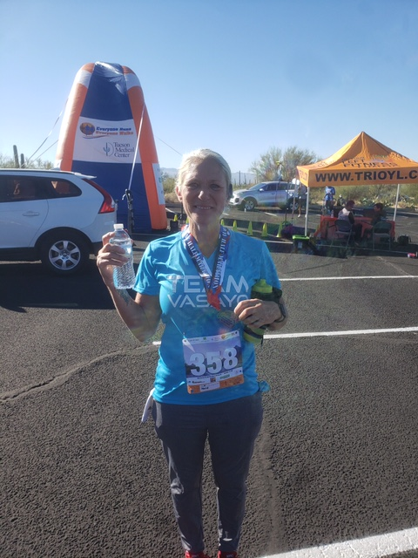
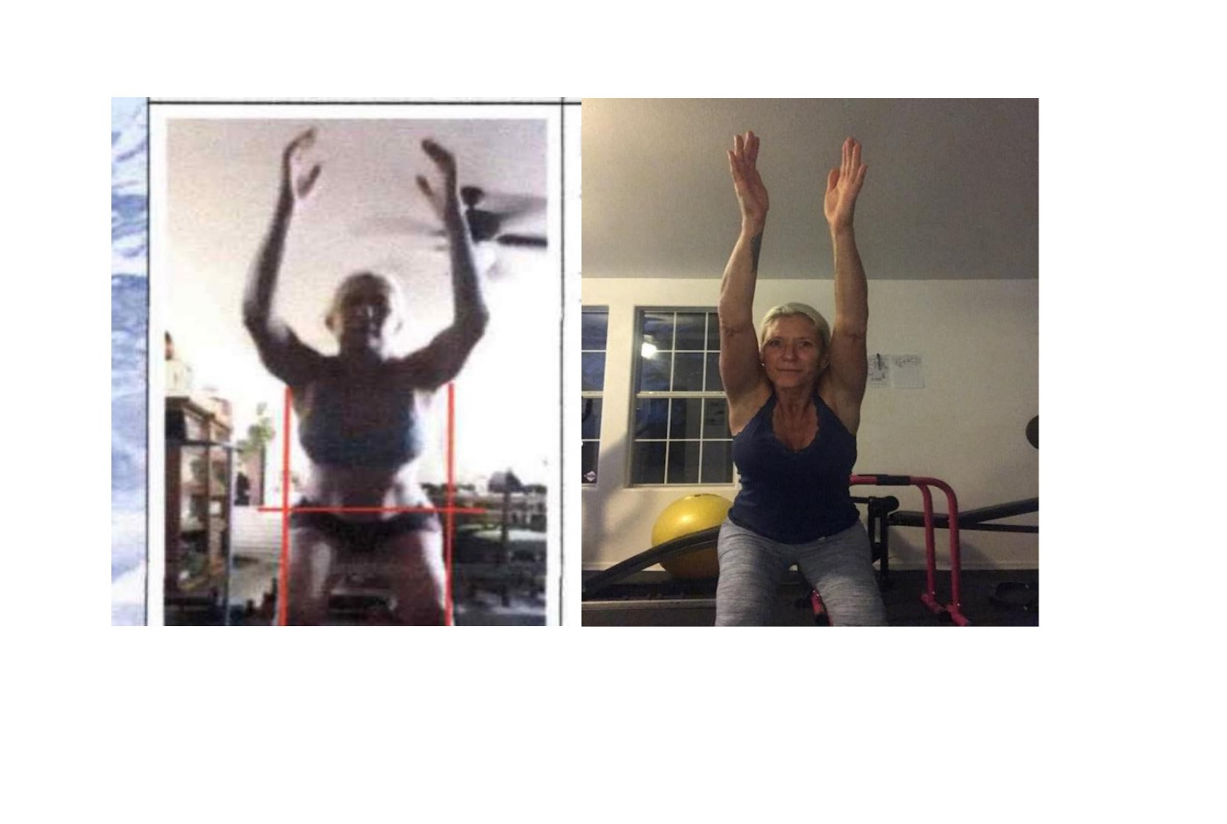
March 2021 / November 2021

